u

EL-GY 9143

3D Computer Vision: Techniques and Applications

NAMAN PATEL

N17075820

**nkp269@nyu.edu**



**Project 4:**

**3D Shape Segmentation**

Due 18th November, 2015

[6 Pages]

**Objective:**

To perform 3D shape segmentation on given 3 centaur models with different poses using K center, K means and Center shift segmentation algorithm.

**Introduction:**

3D models represent a physical body using a collection of points in 3D space, connected by various geometric entities such as triangles, lines, curved surfaces, etc. Being a collection of data (points and other information), 3D models can be created by hand, algorithmically (procedural modeling), or scanned.

Shape analysis is the mainly automatic analysis of geometric shapes, for example using a computer to detect similarly shaped objects in a database or parts that fit together. For a computer to automatically analyze and process geometric shapes, the objects have to be represented in a digital form.

Shape segmentation is the process of partitioning a shape into multiple segments. The goal of segmentation is to simplify and/or change the representation of a shape into something that is more meaningful and easier to analyze.

Shape segmentation is typically used to locate objects and boundaries in a shape. More precisely, shape segmentation is the process of assigning a label to every vertex in a shape such that vertices with the same label share certain characteristic shape.

Our objective is to implement a 3D Shape segmentation of the given shapes using K center, K means and Center Shift segmentation algorithm

These are the steps involved in designing the shape segmentation algorithm using K-center:

* Load the 3D Shape HKS Feature datasets
* Load the off file of each shape and extract vertices and geodesic distances
* Take the mean of all HKS features of every point
* Choose the point with the highest mean HKS feature value as the center point
* Find the point farthest from the center and assign it as the next center
* Cluster all the points by assigning the center nearest to the point to each point.
* Find the mean of the last cluster in the same way as step 3 and 4 and replace it with the last center
* Now, again find the farthest point from both the centers and iterate from step 5 until you get 10 centers
* Cluster using 10 centers by assign nearest center to each point. The vector with the center assignment is the feature vector.
* Do it for all the shapes

Algorithm for Shape Segmentation using K-means:

* Load the 3D Shape HKS Feature datasets
* Load the off file of each shape and extract vertices and geodesic distances
* Concatenate HKS features and Euclidean coordinates
* Randomly initialize 10 centers
* Cluster by assigning each point with its corresponding nearest center (geodesic distance)
* Take the mean of points(HKS feature + coordinates) in each cluster
* Assign the point nearest to the mean as the new center
* Go to step 5 and iterate till convergence
* Calculate the distortion *J*(*c*(*i*),…,*c*(*m*),*μ*1,…,*μK*)=1/*m*∑∣∣*x*(*i*)−*μc*(*i*)∣∣2
* Go to step 4 again and iterate 50 times
* Choose the Feature vector with the least distortion as the feature vector for assignment
* Do it for all the shapes

Algorithm for Shape Segmentation using Center Shift Segmentation:

* Load the off file of each shape and extract vertices and edges information
* Obtain the bi-harmonic distance matrix D from vertices and edges
* Select a starting vertex
* For all the points in the neighborhood of starting vertex, obtain the weighted mean using bi-harmonic kernel density for a given point as the weights
* Find the closest vertex to the weighted mean and assign it as the temporary center
* Apply center shift on temporary center until the bi-harmonic distance between temporary center and starting vertex converges
* The temporary enter after convergence is the termination vertex and is the exemplar of the shape
* Now, once we have the exemplar, the initial segmentation is done. Next we find K exemplars for properly segmenting the shape
* Create an array of perturbed vertices of length K and randomly choose vertex within the exemplar’s neighborhood which is not the exemplar and assign it to perturbed vertices.
* Choose K such vertices and perform center shift on each of them to get the new exemplars
* Do this repeatedly until convergence that is exemplars are no longer getting updated
* Return the exemplars and the vertices in neighborhood of the exemplars are assigned their respective exemplar to get the feature vector.
* This feature vector is used to generate vtk file for the corresponding shape
* Do this for all the shapes.

**Description of Files:**

**kcenter.m:** Function for getting the feature vector for all the shapes using K-center algorithm

**kmeans.m**: Function for getting the feature vector for all the shapes using K-means algorithm

**Running the Program:**

* Run **kcenter.m** to generate .vtk files with K-center segmentation for all the shapes.
* Run **kmeans.m** to generate .vtk files with K-mean segmentation for all the shapes.
* Open Paraview to check all the shapes.

**Experimental Results:**

Centaur 1 K-Center

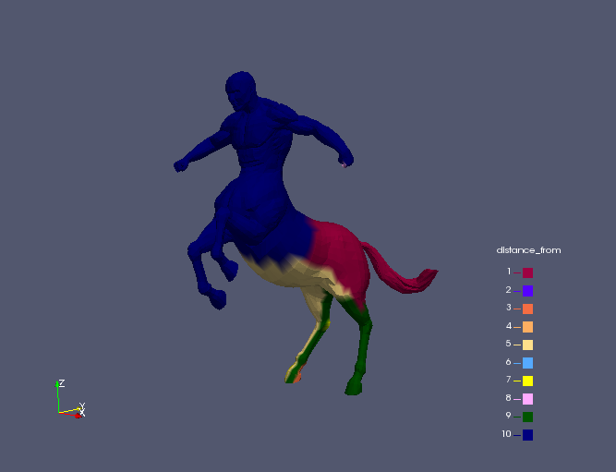

Centaur 2 K-Center

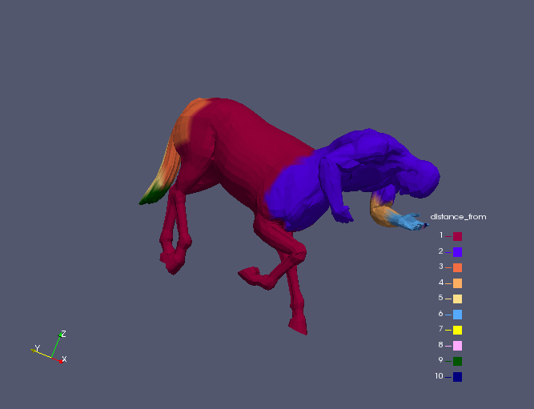

Centaur 3 K-Center

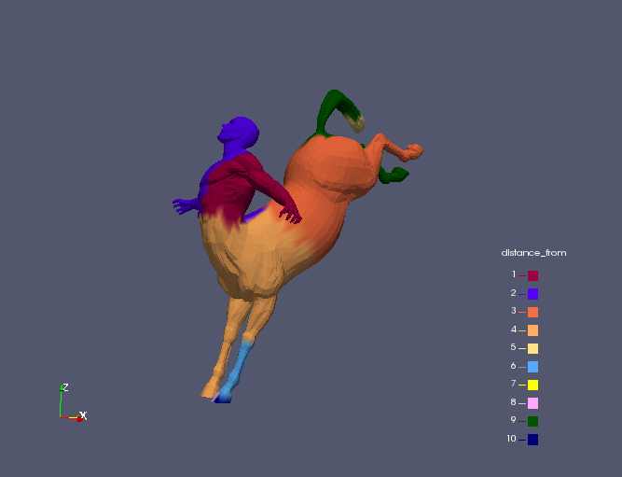

Centaur 1 K-Means

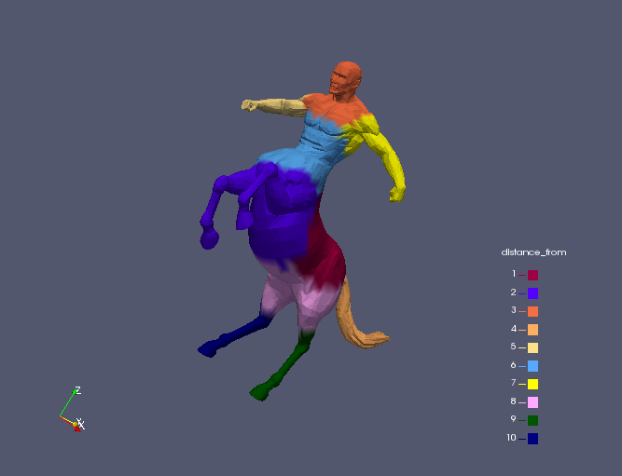

Centaur 2 K-Means

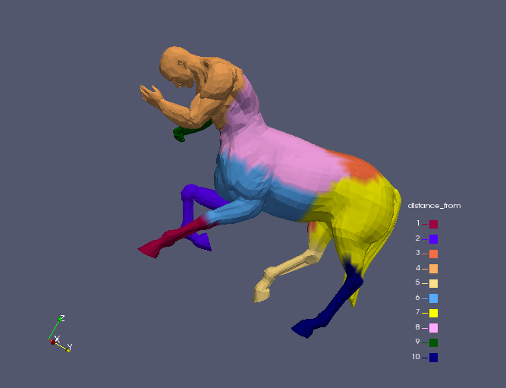

Centaur 3 K-Means

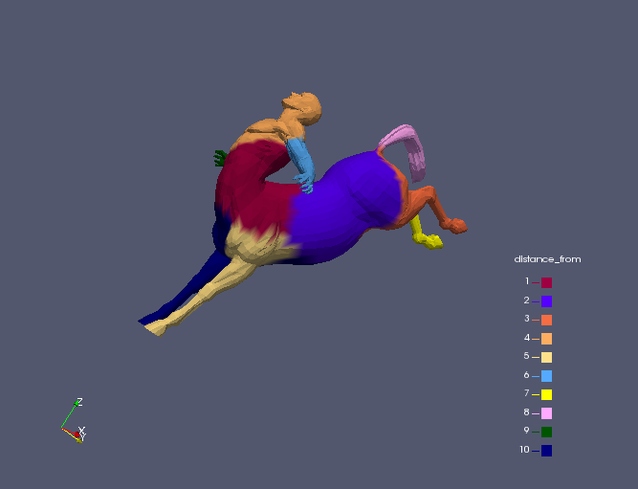

**Conclusion:**

3D Shape segmentation was successfully performed using K means and K center algorithm and center shift algorithm successfully explained.